**Command Prompt**

**Date-09-06-2025**

1.Floder Commands

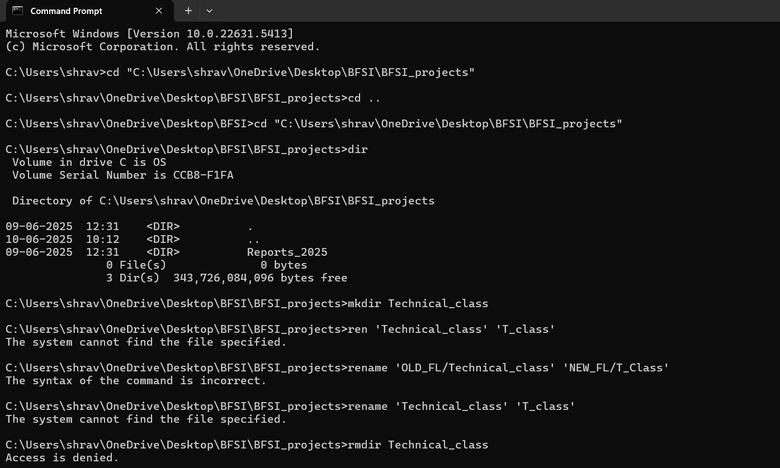

2.File Commands

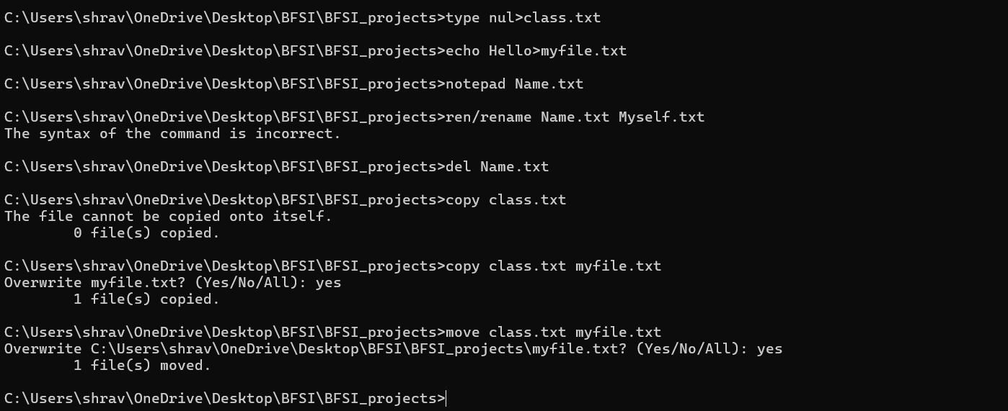

**Date:10-06-2025**

**LINUX LAB Task**

1.Linux Folder Commands, File Commands, System Network

